Practice Work 04 Report: SQL: Data Modification Practice.
Student Name Surname | Student ID | Date
DB2020u00 | EV-00 | 21.04.2021.
3. Solution.
3.1.a. Screenshot “Completed Exercises”. | 3.2. Screenshot “Personal data”.
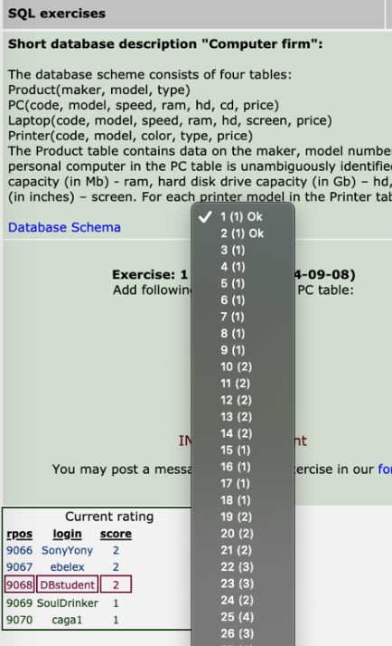 | 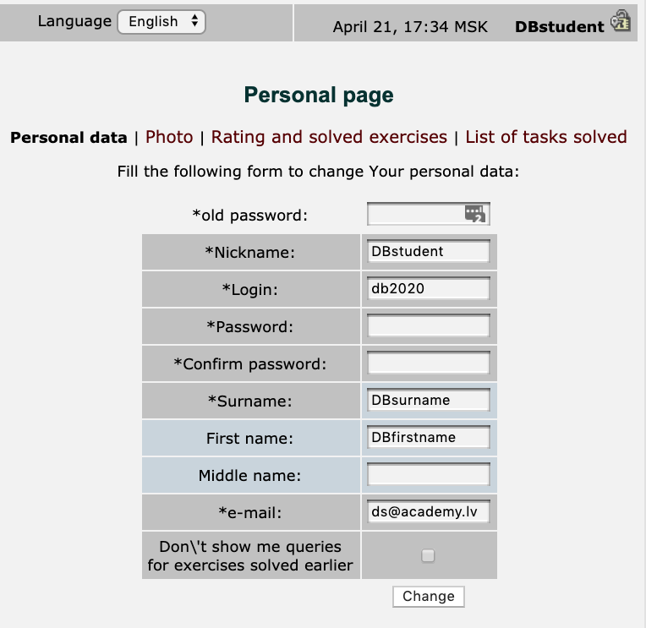

3.3. Screenshot “Rating and solved exercises”. | 3.4.a. Screenshot “List of tasks solved”.
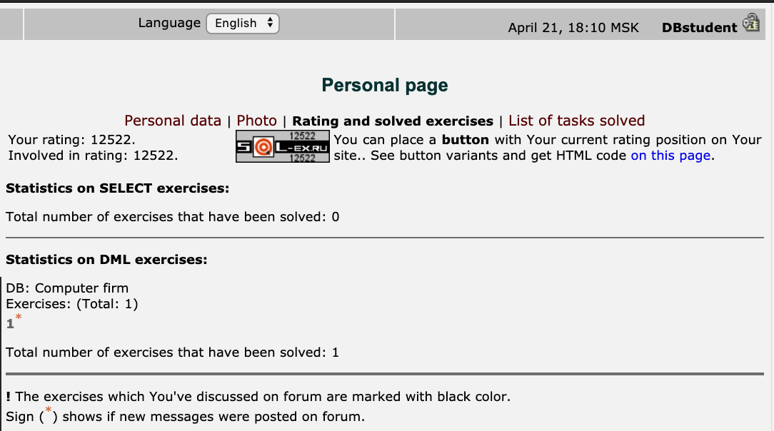 | 