LW-05 Report: SQL: Data Retrieving Exercises (Select).
Student Name Surname | Student ID | Date
Example Variant | EV-00 | 21.04.2025.
3. Solution.
3.1. Screenshot “Completed Exercises”. | 3.2. Screenshot “Personal data”.
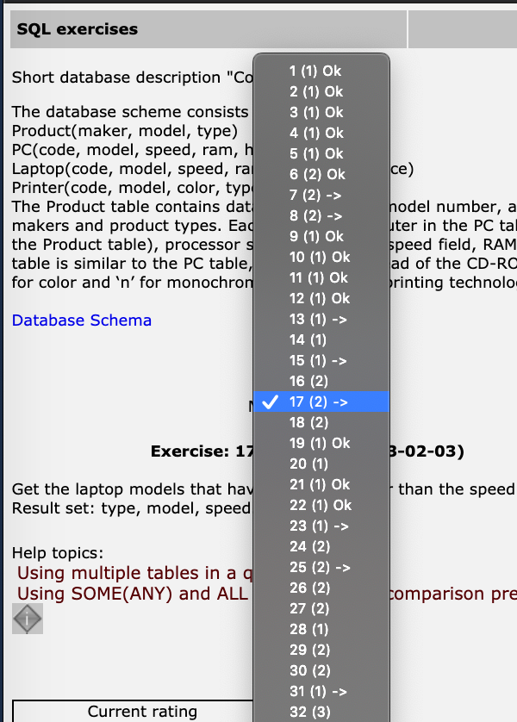 | 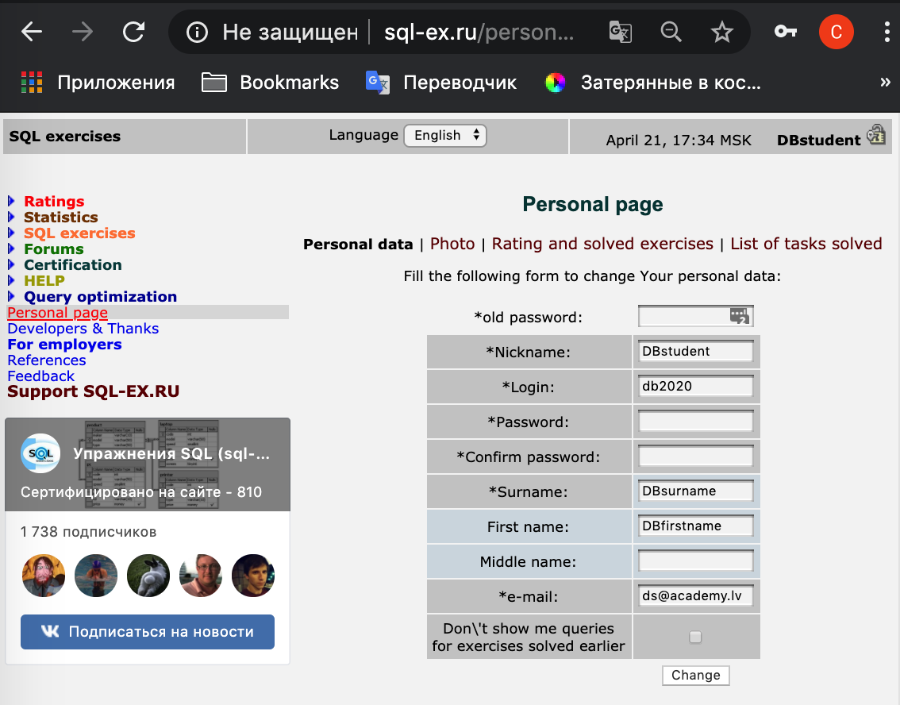

3.3. Screenshot “Rating and solved exercises”. | 3.4. Screenshot “List of tasks solved”.
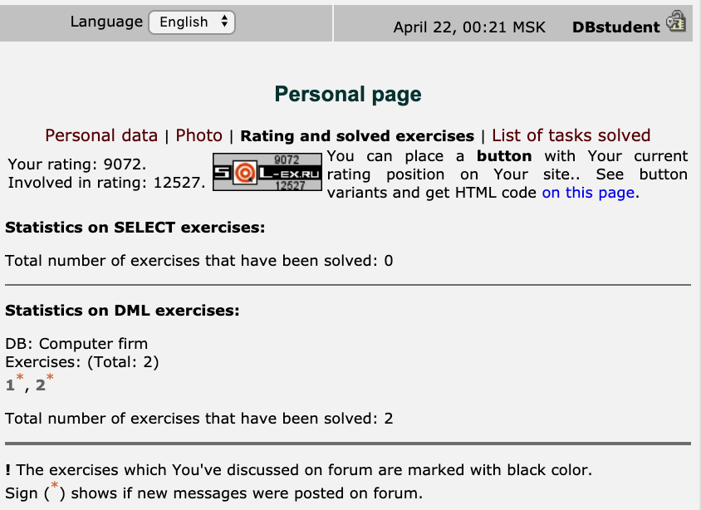 | 