LW-04 Report: SQL - Data Modification Exercises (Insert, Update, Delete, Merge).
Student Name | Group ID | Date
Example Variant | EV-00 | 21.04.2025.
3. Solution.
3.1. Screenshot “Completed Exercises”. | 3.2. Screenshot “Personal data”.
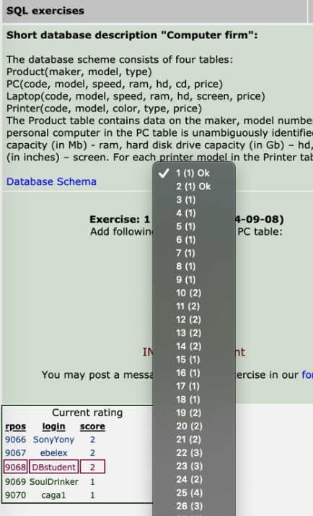 | 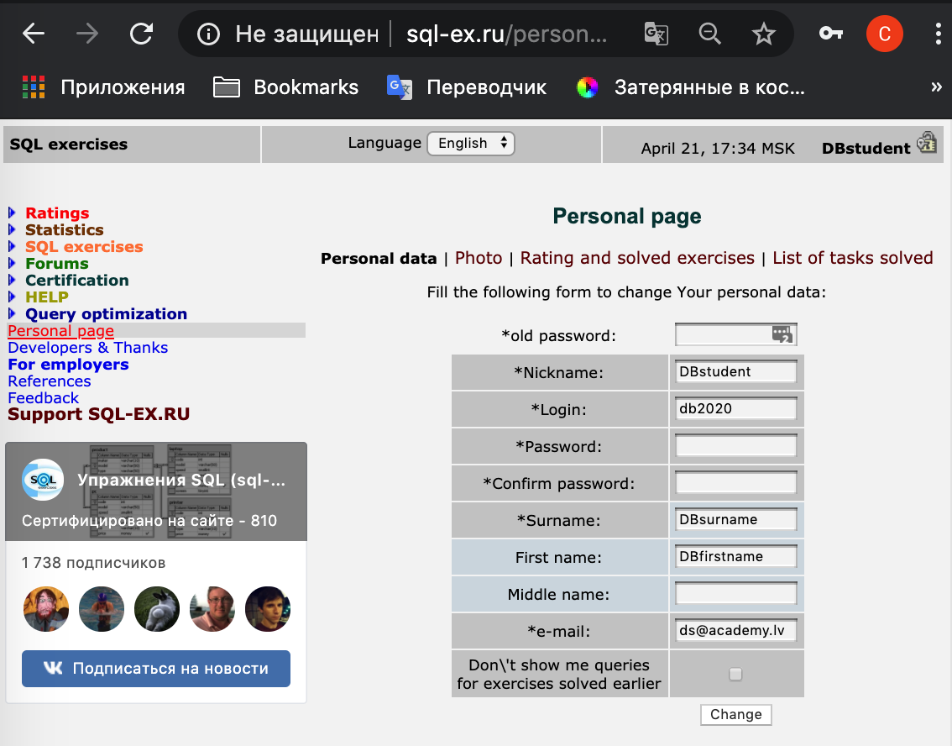

3.3. Screenshot “Rating and solved exercises”. | 3.4. Screenshot “List of tasks solved”.
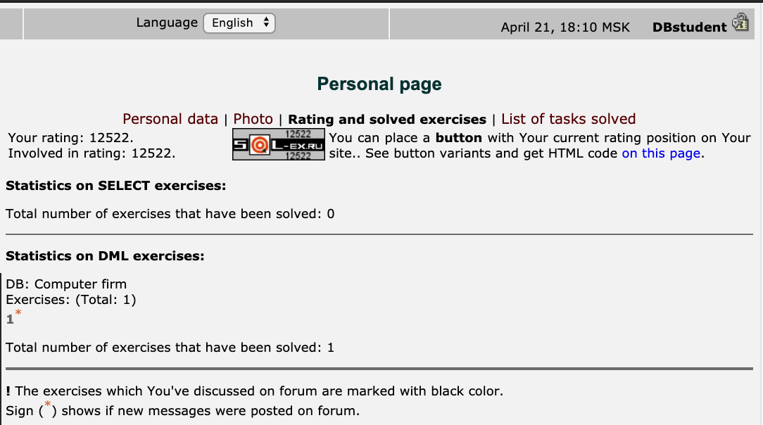 | 