Lab Work 03 Report:
Creation MySQL Database on a XAMPP Stack or a DBMS Hosting.
Student Name Surname | Student ID | Date
Example Variant | EV-00 | 12.03.2021.
1. Lab Assignment.
2.0. Read the topic about web development stacks, free hosting of DBMS and management tools.
2.1. Select Your Individual Variant of the Assignment and, if need, then make correction of the:
- Filled Data Dictionary Table;
- Completed RDM Scheme Image;
- Formed Create.sql Script.
2.2.a. Install XAMPP Stack and import RDM width phpMyAdmin.
2.2.b. Register on DBMS Hosting server and import RDM width phpMyAdmin.
2.3. Normalize MySQL database width phpMyAdmin.
2.4. Populate MySQL database.
2.5. Backup, Drop and Restore MySQL database.
2. Select Variant Nr.
Instruction:  The step by step formation of an individual variant of the assignment from the surname-name to the final number. | Example:  a) Li Yuriy there will be LIYU  b) 12 09 25 21  c)(12+09+25+21)mod10+1=67mod10+1=7+1=8.  d) variant Nr.=8 (CHANGE to 0)

3. Solution.
3.1.1. Correct Filled Data Dictionary Table
Var. Nr | Entity | Attribute Description | Attribute Name | PK, FK | Type | Size | Auto Incr. | Null | Unique | Default | Range
0 | Teachers | Teacher Nr | teacher_id | PK | tinyint |  | Yes |  | Yes |  | <100
 |  | Teacher Name Surname | teacher_name |  | varchar | 20
 |  | Teacher Phone | teacher_phone |  | int |  |  | Yes | Yes |  | 8 dig
 | Students | Student Nr | student_id | PK | smallint |  | Yes |  | Yes |  | <10000
 |  | Name Surname | student_name |  | varchar | 20
 |  | Birthday | student_birthday |  | date |  |  | Yes |  | Null
 |  | Address | student_address |  | varchar | 40 |  | Yes |  | Null
 |  | Phone | student_phone |  | int |  |  | Yes | Yes | Null | 8 dig
 |  | Passport | student_passport |  | char | 15 |  | Yes | Yes | Null
 |  | Language | language |  | enum |  |  | Yes |  | English | English  Russian  Latvian
 |  | Group Nr | group_id | FK | tinyint
 | Contracts | Contract Id | contract_id | PK | smallint |  | Yes |  | Yes |  | <10000
 |  | Number | contract_number |  | char | 20 |  |  | Yes
 |  | Date | contract_date |  | date
 |  | Student Nr | student_id | FK | smallint |  |  |  | Yes
 | Courses | Course Nr | course_id | PK | smallint |  | Yes |  |  |  | <1000
 |  | Duration | course_duration |  | tinyint |  |  | Yes
 |  | Cost Sum | course_cost |  | decimal | 6,2 |  | Yes
 | Groups | Group Nr | group_id | PK | tinyint |  | Yes |  |  |  | <120
 |  | Start Date | group_start |  | date |  |  | Yes
 |  | Finish Date | group_finish |  | date |  |  | Yes
 |  | Course Nr | course_id | FK | smallint
 | CoursesTeachers |  | teacher_id | PK,FK1 | tinyint |  |  |  | Yes
 |  |  | course_id | PK,FK2 | smallint

3.1.2. Correct Completed RDM Scheme Image.
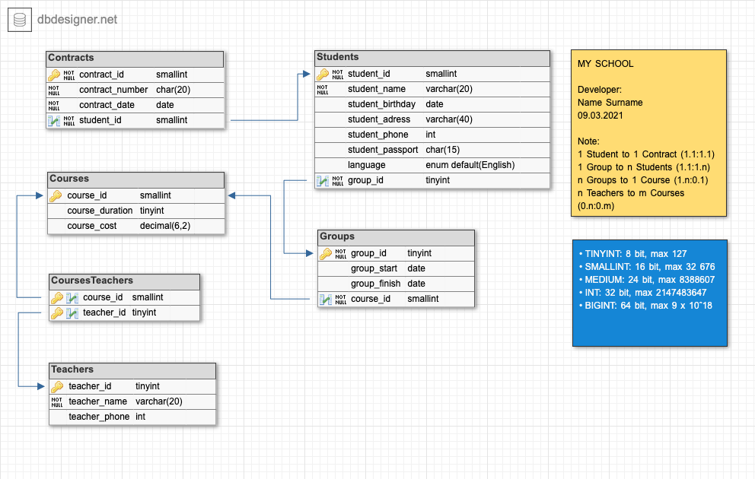

3.1.3. Correct Create.sql Script.
CREATE TABLE `Contracts` (  `contract_id` smallint NOT NULL,  `contract_number` char(20) NOT NULL UNIQUE,  `contract_date` DATE NOT NULL,  `student_id` smallint NOT NULL UNIQUE,  PRIMARY KEY (`contract_id`)  );  CREATE TABLE `Teachers` (  `teacher_id` tinyint NOT NULL,  `teacher_name` varchar(20) NOT NULL,  `teacher_phone` int UNIQUE,  PRIMARY KEY (`teacher_id`)  );  CREATE TABLE `Courses` (  `course_id` smallint NOT NULL,  `course_duration` tinyint,  `course_cost` DECIMAL(6,2),  PRIMARY KEY (`course_id`)  );  CREATE TABLE `Students` (  `student_id` smallint NOT NULL,  `student_name` varchar(20) NOT NULL,  `student_birthday` DATE,  `student_adress` varchar(40),  `student_phone` int UNIQUE,  `student_passport` char(15) UNIQUE,  `language` enum DEFAULT 'English',*/  `language` enum('Russian','English','Latvian') DEAFULT 'English',  `group_id` tinyint NOT NULL,  PRIMARY KEY (`student_id`)  ); | CREATE TABLE `Groups` (  `group_id` tinyint NOT NULL,  `group_start` DATE,  `group_finish` DATE,  `course_id` smallint NOT NULL,  PRIMARY KEY (`group_id`)  );  CREATE TABLE `CoursesTeachers` (  `course_id` smallint NOT NULL,  `teacher_id` tinyint NOT NULL,  PRIMARY KEY (`course_id`,`teacher_id`)  );  ALTER TABLE `Contracts` ADD CONSTRAINT `Contract_fk0` FOREIGN KEY (`student_id`) REFERENCES `Students`(`student_id`);  ALTER TABLE `Students` ADD CONSTRAINT `Student_fk0` FOREIGN KEY (`group_id`) REFERENCES `Groups`(`group_id`);  ALTER TABLE `Groups` ADD CONSTRAINT `Group_fk0` FOREIGN KEY (`course_id`) REFERENCES `Courses`(`course_id`);  ALTER TABLE `CoursesTeachers` ADD CONSTRAINT `CoursesTeachers_fk0` FOREIGN KEY (`course_id`) REFERENCES `Courses`(`course_id`);  ALTER TABLE `CoursesTeachers` ADD CONSTRAINT `CoursesTeachers_fk1` FOREIGN KEY (`teacher_id`) REFERENCES `Teachers`(`teacher_id`);

3.2. Correct Database scheme from phpMyAdmin Designer after normalization check.
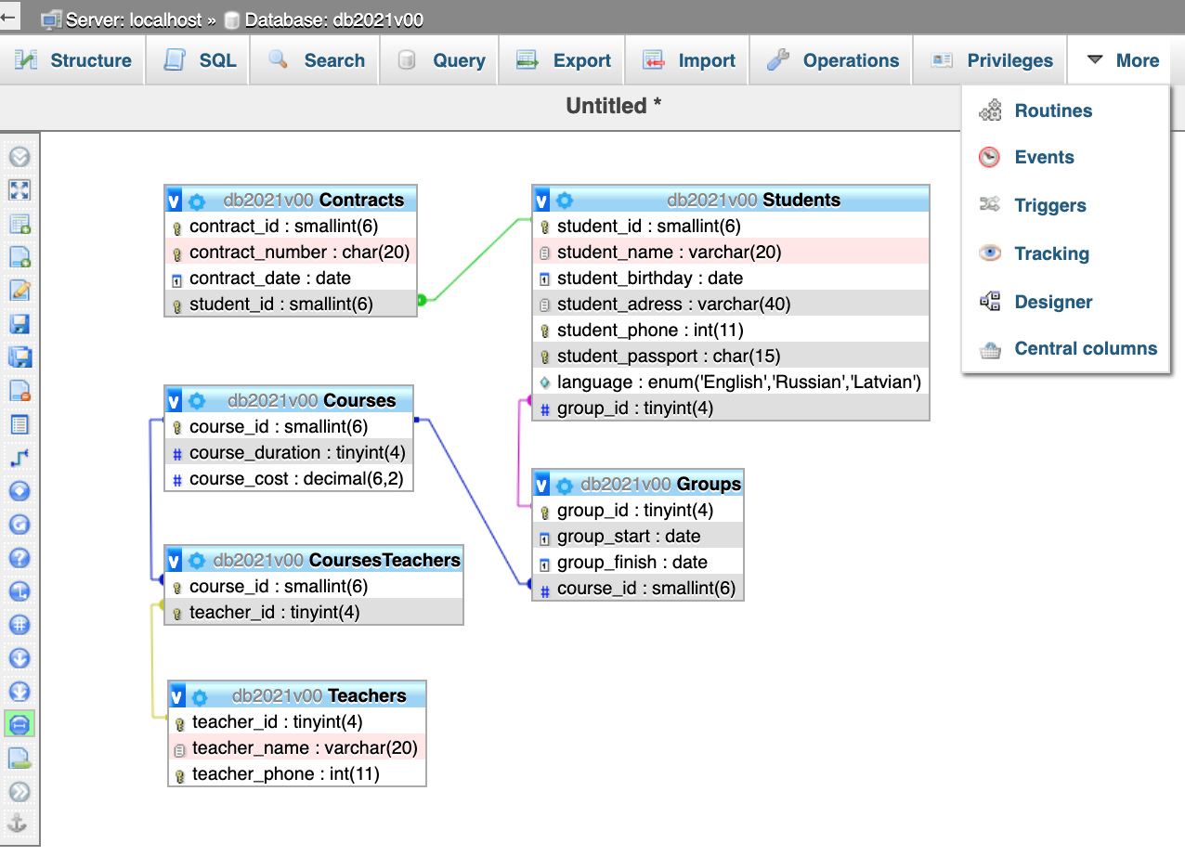

3.3. Conclusion about Check of Normalization with phpMyAdmin.
The following rules of the enterprise are true:
- both student and teacher name is not considered a composite attribute because it saved only surname.
- student address is not considered a composite attribute because it is not used for indexing and searching.
1NF.
All tables have a 1NF, because primary key exists every table, all table columns is atomic, no repeating groups, no redundant columns.
2NF.
Tables Contracts, Students, Courses, Groups, Teachers have a 2NF, because his have 1NF and no partial dependency possible as primary key has just one column.
For table CoursesTeachers primary key (teacher_id, course_id) consist more then 1 column, bet partial dependency not possible because no not key columns.
3NF or BCNF.
The following rules of the enterprise are true:
- student has only one declared address
- several students can live at one address
- both student and teacher have only one or zero or null contact phone number
The Сontracts table has a functional dependency between the non-primary key contract_number and contract_date, but, the contract_number is a superkey, so there is no transitive dependency between contract_id and contract_date.
All Tables have a 3NF or BCNF, because no transitive dependencies between non key attributes.

3.4. Data populating script (insert.sql).
-- INSERT SCRIPT

INSERT INTO `Courses`
(`course_id`, `course_duration`, `course_cost`)
VALUES
('2', '64', '25'),
('3', '64', '125'),
('1', '32', '250'),
('5', '128', '25'),
('4', NULL, NULL);

INSERT INTO `Groups`
(`group_id`, `group_start`, `group_finish`, `course_id`)
VALUES
('234', '2020-02-06', '2020-05-28', '1'),
('233', '2020-01-31', '2020-03-31', '2'),
('232', '2020-02-01', '2020-02-29', '1'),
('230', '2020-02-06', '2020-05-28', '4'),
('131', '2020-02-06', '2020-05-28', '2');

INSERT INTO `Students`
(`student_id`, `student_name`, `student_birthday`, `student_adress`, `student_phone`, `student_passport`, `language`, `group_id`)
VALUES
('35', 'Ivan Green', '1990-03-01', 'Riga, Lomonosov Str. 1, corp. 7', '23467856', 'LV-22 123456789', 'Russian', '234'),
('40', 'Fedor Blue', '1992-04-30', 'Deli, Gandi Str. 10', '12345678', 'IN-02 56789', 'English', '233'),
('41', 'Nicol White', '2012-12-12', ‘NY, Wach Str. 23, corp. 7, ap.55', '22334455', 'USA-12 123789', 'Latvian', '233'),
('42', 'Ivan Green', '2000-03-01', 'Riga, Lomonosov Str. 1, corp. 7', '27654856', 'LV-23 23457789', 'Russian', '234'),
('44', 'Piter Black', '2012-12-12', 'Moscow, Lenin Str. 103', '29235656', 'RU-123 674589', 'Russian', '131');

-- INSERT INTO `Contracts`

-- INSERT INTO `Teachers`

-- INSERT INTO `CoursesTeachers`

3.5. Database backup script (backup.sql).

-- phpMyAdmin SQL Dump
-- version 5.0.1
-- https://www.phpmyadmin.net/
--
-- Host: 127.0.0.1:3306
-- Generation Time: Mar 11, 2020 at 11:58 PM
-- Server version: 8.0.19
-- PHP Version: 7.2.24-0ubuntu0.18.04.3

SET SQL_MODE = "NO_AUTO_VALUE_ON_ZERO";
SET AUTOCOMMIT = 0;
START TRANSACTION;
SET time_zone = "+00:00";

/*!40101 SET @OLD_CHARACTER_SET_CLIENT=@@CHARACTER_SET_CLIENT */;
/*!40101 SET @OLD_CHARACTER_SET_RESULTS=@@CHARACTER_SET_RESULTS */;
/*!40101 SET @OLD_COLLATION_CONNECTION=@@COLLATION_CONNECTION */;
/*!40101 SET NAMES utf8mb4 */;

--
-- Database: `db2021v00`
--

-- --------------------------------------------------------

--
-- Table structure for table `Contracts`
--

CREATE TABLE `Contracts` (
`contract_id` int NOT NULL,
`contract_number` varchar(20) NOT NULL,
`contract_date` date NOT NULL,
`student_id` int NOT NULL
) ENGINE=InnoDB DEFAULT CHARSET=utf8mb4 COLLATE=utf8mb4_0900_ai_ci;

-- --------------------------------------------------------

--
-- Table structure for table `Courses`
--

CREATE TABLE `Courses` (
`course_id` int NOT NULL,
`course_duration` int DEFAULT NULL,
`course_cost` decimal(10,0) DEFAULT NULL
) ENGINE=InnoDB DEFAULT CHARSET=utf8mb4 COLLATE=utf8mb4_0900_ai_ci;

--
-- Dumping data for table `Courses`
--

INSERT INTO `Courses` (`course_id`, `course_duration`, `course_cost`) VALUES
(1, 32, '250'),
(2, 64, '25'),
(3, 64, '125'),
(4, NULL, NULL),
(5, 128, '25');

-- --------------------------------------------------------

--
-- Table structure for table `CoursesTeachers`
--

CREATE TABLE `CoursesTeachers` (
`course_id` int NOT NULL,
`teacher_id` int NOT NULL
) ENGINE=InnoDB DEFAULT CHARSET=utf8mb4 COLLATE=utf8mb4_0900_ai_ci;

-- --------------------------------------------------------

--
-- Table structure for table `Groups`
--

CREATE TABLE `Groups` (
`group_id` int NOT NULL,
`group_start` date DEFAULT NULL,
`group_finish` date DEFAULT NULL,
`course_id` int NOT NULL
) ENGINE=InnoDB DEFAULT CHARSET=utf8mb4 COLLATE=utf8mb4_0900_ai_ci;

--
-- Dumping data for table `Groups`
--

INSERT INTO `Groups` (`group_id`, `group_start`, `group_finish`, `course_id`) VALUES
(131, '2020-02-06', '2020-05-28', 2),
(230, '2020-02-06', '2020-05-28', 4),
(232, '2020-02-01', '2020-02-29', 1),
(233, '2020-01-31', '2020-03-31', 2),
(234, '2020-02-06', '2020-05-28', 1);

-- --------------------------------------------------------

--
-- Table structure for table `Students`
--

CREATE TABLE `Students` (
`student_id` int NOT NULL,
`student_name` varchar(20) NOT NULL,
`student_birthday` date DEFAULT NULL,
`student_adress` varchar(40) DEFAULT NULL,
`student_phone` int DEFAULT NULL,
`student_passport` varchar(15) DEFAULT NULL,
`language` varchar(10) DEFAULT NULL,
`group_id` int NOT NULL
) ENGINE=InnoDB DEFAULT CHARSET=utf8mb4 COLLATE=utf8mb4_0900_ai_ci;

--
-- Dumping data for table `Students`
--

INSERT INTO `Students` (`student_id`, `student_name`, `student_birthday`, `student_adress`, `student_phone`, `student_passport`, `language`, `group_id`) VALUES
(35, 'Ivan Green', '1990-03-01', 'Riga, Lomonosov Str. 1, corp. 7', 23467856, 'LV-22 123456789', 'Russian', 234),
(40, 'Fedor Blue', '1992-04-30', 'Deli, Gandi Str. 10', 12345678, 'IN-02 56789', 'English', 233),
(41, 'Nicol White', '2012-12-12', 'NY, Wach Str. 23, corp. 7, ap.55', 22334455, 'USA-12 123789', 'Latvian', 233),
(42, 'Ivan Green', '2000-03-01', 'Riga, Lomonosov Str. 1, corp. 7', 27654856, 'LV-23 23457789', 'Russian', 234),
(44, 'Piter Black', '2012-12-12', 'Moscow, Lenin Str. 103', 29235656, 'RU-123 674589', 'Russian', 131);

-- --------------------------------------------------------

--
-- Table structure for table `Teachers`
--

CREATE TABLE `Teachers` (
`teacher_id` int NOT NULL,
`teacher_name` varchar(20) NOT NULL,
`teacher_phone` int DEFAULT NULL
) ENGINE=InnoDB DEFAULT CHARSET=utf8mb4 COLLATE=utf8mb4_0900_ai_ci;

--
-- Indexes for dumped tables
--

--
-- Indexes for table `Contracts`
--
ALTER TABLE `Contracts`
ADD PRIMARY KEY (`contract_id`),
ADD UNIQUE KEY `contract_number` (`contract_number`),
ADD UNIQUE KEY `student_id` (`student_id`);

--
-- Indexes for table `Courses`
--
ALTER TABLE `Courses`
ADD PRIMARY KEY (`course_id`);

--
-- Indexes for table `CoursesTeachers`
--
ALTER TABLE `CoursesTeachers`
ADD PRIMARY KEY (`course_id`,`teacher_id`),
ADD KEY `CoursesTeachers_fk1` (`teacher_id`);

--
-- Indexes for table `Groups`
--
ALTER TABLE `Groups`
ADD PRIMARY KEY (`group_id`),
ADD KEY `Groups_fk0` (`course_id`);

--
-- Indexes for table `Students`
--
ALTER TABLE `Students`
ADD PRIMARY KEY (`student_id`),
ADD UNIQUE KEY `student_phone` (`student_phone`),
ADD UNIQUE KEY `student_passport` (`student_passport`),
ADD KEY `Students_fk0` (`group_id`);

--
-- Indexes for table `Teachers`
--
ALTER TABLE `Teachers`
ADD PRIMARY KEY (`teacher_id`),
ADD UNIQUE KEY `teacher_phone` (`teacher_phone`);

--
-- AUTO_INCREMENT for dumped tables
--

--
-- AUTO_INCREMENT for table `Contracts`
--
ALTER TABLE `Contracts`
MODIFY `contract_id` int NOT NULL AUTO_INCREMENT;

--
-- AUTO_INCREMENT for table `Courses`
--
ALTER TABLE `Courses`
MODIFY `course_id` int NOT NULL AUTO_INCREMENT, AUTO_INCREMENT=6;

--
-- AUTO_INCREMENT for table `Groups`
--
ALTER TABLE `Groups`
MODIFY `group_id` int NOT NULL AUTO_INCREMENT, AUTO_INCREMENT=235;

--
-- AUTO_INCREMENT for table `Students`
--
ALTER TABLE `Students`
MODIFY `student_id` int NOT NULL AUTO_INCREMENT, AUTO_INCREMENT=45;

--
-- AUTO_INCREMENT for table `Teachers`
--
ALTER TABLE `Teachers`
MODIFY `teacher_id` int NOT NULL AUTO_INCREMENT;

--
-- Constraints for dumped tables
--

--
-- Constraints for table `Contracts`
--
ALTER TABLE `Contracts`
ADD CONSTRAINT `Contracts_fk0` FOREIGN KEY (`student_id`) REFERENCES `Students` (`student_id`);

--
-- Constraints for table `CoursesTeachers`
--
ALTER TABLE `CoursesTeachers`
ADD CONSTRAINT `CoursesTeachers_fk0` FOREIGN KEY (`course_id`) REFERENCES `Courses` (`course_id`),
ADD CONSTRAINT `CoursesTeachers_fk1` FOREIGN KEY (`teacher_id`) REFERENCES `Teachers` (`teacher_id`);

--
-- Constraints for table `Groups`
--
ALTER TABLE `Group`
ADD CONSTRAINT `Groups_fk0` FOREIGN KEY (`course_id`) REFERENCES `Courses` (`course_id`);

--
-- Constraints for table `Students`
--
ALTER TABLE `Students`
ADD CONSTRAINT `Students_fk0` FOREIGN KEY (`group_id`) REFERENCES `Groups` (`group_id`);
COMMIT;

/*!40101 SET CHARACTER_SET_CLIENT=@OLD_CHARACTER_SET_CLIENT */;
/*!40101 SET CHARACTER_SET_RESULTS=@OLD_CHARACTER_SET_RESULTS */;
/*!40101 SET COLLATION_CONNECTION=@OLD_COLLATION_CONNECTION */;

