Lab Work 02 Report: Creation Relation Data Model with Online CASE Tools.
Student Name Surname | Student ID | Date
Example Variant | EV-00 | 14.03.2021.
1. Lab Assignment.
2.0. Select Your Individual Variant of the Assignment.
2.1. Register on DbDesigner.net Site.
2.2. Work with DbDesigner RDM Scheme.
2.3. Fill in a Data Dictionary.
2.4. Create Relation Data Model Scheme.
2.5. Share and Export DbDesigner RDM Scheme to sql.
2. Select Variant Nr.
Instruction:  The step by step formation of an individual variant of the assignment from the surname-name to the final number. | Example:  a) Li Yuriy there will be LIYU  b) 12 09 25 21  c)(12+09+25+21)mod10+1=67mod10+1=7+1=8.  d) variant Nr.=8 (CHANGE to 0)

3. Solution.
3.1. Filled Data Dictionary Table
Var. Nr | Entity | Attribute Description | Attribute Name | PK, FK | Type | Size | Auto Incr. | Null | Unique | Default | Range
0 | Teachers | Teacher Nr | teacher_id | PK | tinyint |  | Yes |  | Yes |  | <100
 |  | Teacher Name Surname | teacher_name |  | varchar | 20
 |  | Teacher Phone | teacher_phone |  | int |  |  | Yes | Yes |  | 8 dig
 | Students | Student Nr | student_id | PK | smallint |  | Yes |  | Yes |  | <10000
 |  | Name Surname | student_name |  | varchar | 20
 |  | Birthday | student_birthday |  | date |  |  | Yes |  | Null
 |  | Address | student_address |  | varchar | 40 |  | Yes |  | Null
 |  | Phone | student_phone |  | int |  |  | Yes | Yes | Null | 8 dig
 |  | Passport | student_passport |  | char | 15 |  | Yes | Yes | Null
 |  | Language | language |  | enum |  |  | Yes |  | English | English  Russian  Latvian
 |  | Group Nr | group_id | FK | tinyint
 | Contracts | Contract Id | contract_id | PK | smallint |  | Yes |  | Yes |  | <10000
 |  | Number | contract_number |  | char | 20 |  |  | Yes
 |  | Date | contract_date |  | date
 |  | Student Nr | student_id | FK | smallint |  |  |  | Yes
 | Courses | Course Nr | course_id | PK | smallint |  | Yes |  |  |  | <1000
 |  | Duration | course_duration |  | tinyint |  |  | Yes
 |  | Cost Sum | course_cost |  | decimal | 6,2 |  | Yes
 | Groups | Group Nr | group_id | PK | tinyint |  | Yes |  |  |  | <120
 |  | Start Date | group_start |  | date |  |  | Yes
 |  | Finish Date | group_finish |  | date |  |  | Yes
 |  | Course Nr | course_id | FK | smallint
 | CoursesTeachers |  | teacher_id | PK,FK1 | tinyint |  |  |  | Yes
 |  |  | course_id | PK,FK2 | smallint

3.2. Completed RDM Scheme Image.
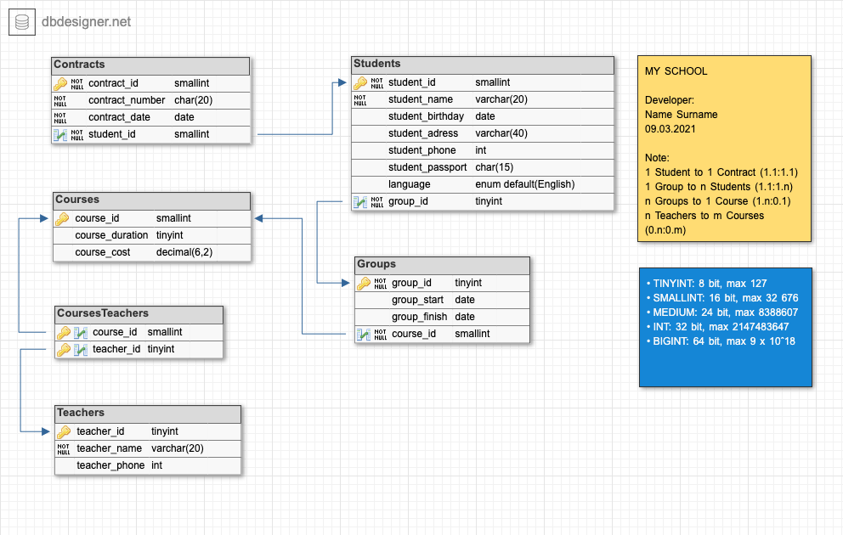

3.3. RDM Scheme Share Link.
https://dbdesigner.page.link/5Mt8vxhHTQzm7cBT9 (mysql)
3.4. Create.sql Script.
CREATE TABLE `Contracts` (
`contract_id` smallint NOT NULL,
`contract_number` char(20) NOT NULL UNIQUE,
`contract_date` DATE NOT NULL,
`student_id` smallint NOT NULL UNIQUE,
PRIMARY KEY (`contract_id`)
);

CREATE TABLE `Teachers` (
`teacher_id` tinyint NOT NULL,
`teacher_name` varchar(20) NOT NULL,
`teacher_phone` int UNIQUE,
PRIMARY KEY (`teacher_id`)
);

CREATE TABLE `Courses` (
`course_id` smallint NOT NULL,
`course_duration` tinyint,
`course_cost` DECIMAL(6,2),
PRIMARY KEY (`course_id`)
);

CREATE TABLE `Students` (
`student_id` smallint NOT NULL,
`student_name` varchar(20) NOT NULL,
`student_birthday` DATE,
`student_adress` varchar(40),
`student_phone` int UNIQUE,
`student_passport` char(15) UNIQUE,
`language` enum DEFAULT 'English',*/
`language` enum('Russian','English','Latvian') DEAFULT 'English',
`group_id` tinyint NOT NULL,
PRIMARY KEY (`student_id`)
);

CREATE TABLE `Groups` (
`group_id` tinyint NOT NULL,
`group_start` DATE,
`group_finish` DATE,
`course_id` smallint NOT NULL,
PRIMARY KEY (`group_id`)
);

CREATE TABLE `CoursesTeachers` (
`course_id` smallint NOT NULL,
`teacher_id` tinyint NOT NULL,
PRIMARY KEY (`course_id`,`teacher_id`)
);

ALTER TABLE `Contracts` ADD CONSTRAINT `Contract_fk0` FOREIGN KEY (`student_id`) REFERENCES `Students`(`student_id`);

ALTER TABLE `Students` ADD CONSTRAINT `Student_fk0` FOREIGN KEY (`group_id`) REFERENCES `Groups`(`group_id`);

ALTER TABLE `Groups` ADD CONSTRAINT `Group_fk0` FOREIGN KEY (`course_id`) REFERENCES `Courses`(`course_id`);

ALTER TABLE `CoursesTeachers` ADD CONSTRAINT `CoursesTeachers_fk0` FOREIGN KEY (`course_id`) REFERENCES `Courses`(`course_id`);

ALTER TABLE `CoursesTeachers` ADD CONSTRAINT `CoursesTeachers_fk1` FOREIGN KEY (`teacher_id`) REFERENCES `Teachers`(`teacher_id`);

