LW-02 Report: Creation Relation Data Model with Online CASE Tools.

|  |  |  |
| --- | --- | --- |
| **Student Name** | **Group ID** | **Date** |
| Example Variant | EV-00 | 14.03.2025. |

1. Lab Assignment.

2.0. Select Your Individual Variant of the Assignment.

2.1. Register on DbDesigner.net Site.

2.2. Training work with DbDesigner.net

2.3. Fill in Initial Data Dictionary. Select name for your DB.

2.4. Create an Initial RDM Scheme.

2.5. Create Share Link to Initial RDM.

2.6. Export Initial RDM Scheme to sql-code (create.sql) and make manually corrections (if need).

2. Select Variant Nr.

|  |  |
| --- | --- |
| Instruction:  The step by step formation of an individual variant of the assignment from the student name to the final number. | *Example:*  *a)* Yuriy Li there will be LIYU  *b)* 12 09 25 21  *c)*(12+09+25+21)mod10+1=67mod10+1=7+1=8.  d) variant Nr.=8 (Changed to 0) |

3. Solution.

3.1. Initial Data Dictionary Table for “My School”. (added attributes).

|  |  |  |  |  |  |  |  |  |  |  |  |
| --- | --- | --- | --- | --- | --- | --- | --- | --- | --- | --- | --- |
| **Var. Nr** | **Entity** | **Attribute Description** | **Attribute Name** | **PK, FK** | **Type** | **Size** | **Auto Incr.** | **Null** | **Unique** | **Default** | **Range** |
| **0** | Teachers | Teacher Nr | teacher_id | PK | tinyint | 3 | Yes |  | Yes |  | <250 |
| Teacher Name Surname | teacher_name |  | varchar | 20 |  |  |  |  |  |
| Teacher Phone | teacher_phone |  | int |  |  | Yes |  |  | 8 dig |
| Course Nr | course_id | FK | smallint |  |  |  |  |  |  |
| Students | Student Nr | student_id | PK | smallint | 4 | Yes |  | Yes |  | <10000 |
| Name Surname | student_name |  | varchar | 20 |  |  |  |  |  |
| Birthday | student_birthday |  | date |  |  | Yes |  |  |  |
| Address | student_address |  | varchar | 40 |  | Yes |  |  |  |
| Phone | student_phone |  | int |  |  | Yes |  |  | 8 dig |
| Passport | student_passport |  | char | 15 |  | Yes | Yes |  |  |
| Language | language |  | enum |  |  |  |  | English | English  Russian  Latvian |
| Group Nr | group_id | FK | tinyint |  |  |  |  |  |  |
| Contracts | Contract Id | contract_id | PK | smallint | 4 | Yes |  | Yes |  | <10000 |
| Number | contract_number |  | char | 20 |  |  | Yes |  |  |
| Date | contract_date |  | date |  |  |  |  |  |  |
| Student Nr | student_id | FK | smallint |  |  |  | Yes |  |  |
| Courses | Course Nr | course_id | PK | smallint | 3 | Yes |  | Yes |  | <1000 |
| Course Name | course_name |  | varchar | 50 |  |  | Yes |  |  |
| Duration | course_duration |  | tinyint |  |  |  |  |  |  |
| Cost Sum | course_cost |  | decimal | 6,2 |  | Yes |  |  |  |
| Groups | Group Nr | group_id | PK | tinyint | 3 | Yes |  | Yes |  | <1000 |
| Group Name | group_name |  | char | 8 |  |  | Yes |  |  |
| Start Date | group_start |  | date |  |  | Yes |  |  |  |
| Finish Date | group_finish |  | date |  |  | Yes |  |  |  |
| Course Nr | course_id | FK | smallint |  |  | Yes |  |  | <1000 |

3.2. Initial RDM Scheme.

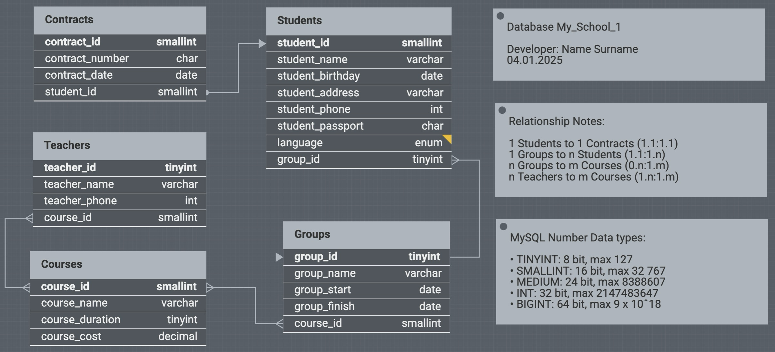

3.3. Initial RDM Share Link.

Link to My_School_1_(mysql) RDM

<https://erd.dbdesigner.net/designer/schema/1738802793-my_school_1_-mysql>  
or  
<https://dbdesigner.page.link/8s1yNvU5oWm22Et99>

3.4. Create.sql code.

CREATE TABLE IF NOT EXISTS `Teachers` (

`teacher_id` tinyint AUTO_INCREMENT NOT NULL UNIQUE,

`teacher_name` varchar(20) NOT NULL,

`teacher_phone` int,

`course_id` smallint NOT NULL,

PRIMARY KEY (`teacher_id`)

);

CREATE TABLE IF NOT EXISTS `Courses` (

`course_id` smallint AUTO_INCREMENT NOT NULL,

`course_name` varchar(50) NOT NULL UNIQUE,

`course_duration` tinyint NOT NULL,

`course_cost` decimal(6,2),

PRIMARY KEY (`course_id`)

);

CREATE TABLE IF NOT EXISTS `Groups` (

`group_id` tinyint AUTO_INCREMENT NOT NULL UNIQUE,

`group_name` varchar(8) NOT NULL UNIQUE,

`group_start` date,

`group_finish` date,

`course_id` smallint NOT NULL,

PRIMARY KEY (`group_id`)

);

CREATE TABLE IF NOT EXISTS `Students` (

`student_id` smallint AUTO_INCREMENT NOT NULL UNIQUE,

`student_name` varchar(20) NOT NULL,

`student_birthday` date,

`student_address` varchar(40),

`student_phone` int,

`student_passport` char(15) UNIQUE,

`language` enum NOT NULL DEFAULT 'Latvian',

`group_id` tinyint NOT NULL,

PRIMARY KEY (`student_id`)

);

CREATE TABLE IF NOT EXISTS `Contracts` (

`contract_id` smallint AUTO_INCREMENT NOT NULL UNIQUE,

`contract_number` char(20) NOT NULL UNIQUE,

`contract_date` date NOT NULL,

`student_id` smallint NOT NULL UNIQUE,

PRIMARY KEY (`contract_id`)

);

ALTER TABLE `Teachers` ADD CONSTRAINT `Teachers_fk3` FOREIGN KEY (`course_id`) REFERENCES `Courses`(`course_id`);

ALTER TABLE `Groups` ADD CONSTRAINT `Groups_fk4` FOREIGN KEY (`course_id`) REFERENCES `Courses`(`course_id`);

ALTER TABLE `Students` ADD CONSTRAINT `Students_fk7` FOREIGN KEY (`group_id`) REFERENCES `Groups`(`group_id`);

ALTER TABLE `Contracts` ADD CONSTRAINT `Contracts_fk3` FOREIGN KEY (`student_id`) REFERENCES `Students`(`student_id`);