Lab Work 01 Report: Creation ER Diagrams with Online CASE Tools.
Student Name Surname | Student ID | Date
Example Variant | EV-00 | 31.01.2020.
1. Lab Assignment.
1. Document any assumptions and restrictions then you make on your variant of Enterprise information.
2. Create Basic Concept Model as ERD on Chen’s notation with draw.io site.
2.1. Register on Draw.io site (https://www.draw.io/).
2.2. Create ERD Chen’s notation, show entity names, primary keys, attributes, relationships and cardinality.
2.3. Export ERD to PNG and insert picture to your Report (File/Export as/PNG…).
3. Create Keys Concept Model as ERD on Crow’s Foot notation with LucidChart.com.
3.1. Register on LucidChart site (https://www.lucidchart.com/).
3.2. Create ERD Crow’s Foot notation, show entity names, primary keys, foreign keys, attributes, relationships and cardinality.
3.3. Transform many-to-many relationship (n:m) to new Associative Entity.
3.4. If you think the ERD is incomplete, list other data the database should store & adjust your design to incorporate these additions.
3.5. Export ERD to PNG and insert picture to your Report (File/Export/PNG…).
4. Make a Publish Link to ERD and insert link-code to your Report.
4.1. Make a Publish Link to ERD for Draw.io (File/Publish/Link…).
4.2. Make a Publish Link to ERD for LucidChart.com (File/Share Document/Anyone with the link can view).
5. Create Database Scheme on Text notation.
5.1. Show entity names, attributes, primary keys, foreign keys, for each entity.
5.2. For each attribute, determine its domain of values, whether Null is an acceptable value, and, if acceptable, what value indicates Null.
2. Select Variant Nr.
Instruction:  The step by step formation of an individual variant of the assignment from the surname-name to the final number. | Example:  a) Li Yuriy there will be LIYU  b) 12 09 25 21  c)(12+09+25+21)mod16+1=67mod16+1=3+1=4.  d) variant Nr.=4 (CHANGE to 0)
3. Description of the Subject Area “Manufacture” (var.0)
A manufacturing company produces products. The following product information is stored: product name, product ID and quantity on hand. These products are made up of many components. Each component can be supplied by one or more suppliers. The following component information is kept: component ID, name, description, suppliers who supply them, and products in which they are used.
4. Solution.
4.1. Assumptions and restrictions
Manufacture Databases design base on the following business rules:
- A Supplier can exist without providing Components.
- A Component does not have to be associated with a Supplier.
- A Component does not have to be associated with a Product. Not all Components are used in Products.
- A Product cannot exist without Components.

4.2. Basic Concept Model. ERD on Chen’s notation with Draw.io site
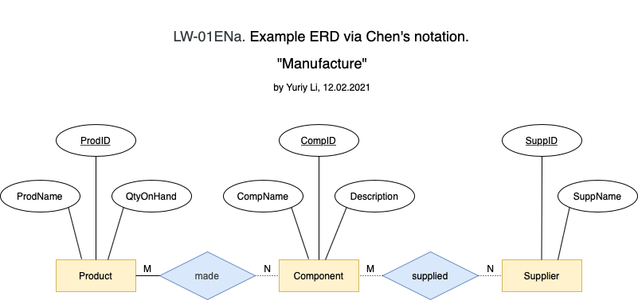

4.3. Keys Concept Model. ERD on Crow’s Foot notation with LucidChart.com
a) After transforming the many-to-many relationship, a new associative entities, CompSupp and Build, was added.
b) After analysis, a new QtyOfComp attribute (Number of components in the product) was added to the Build associative entity.

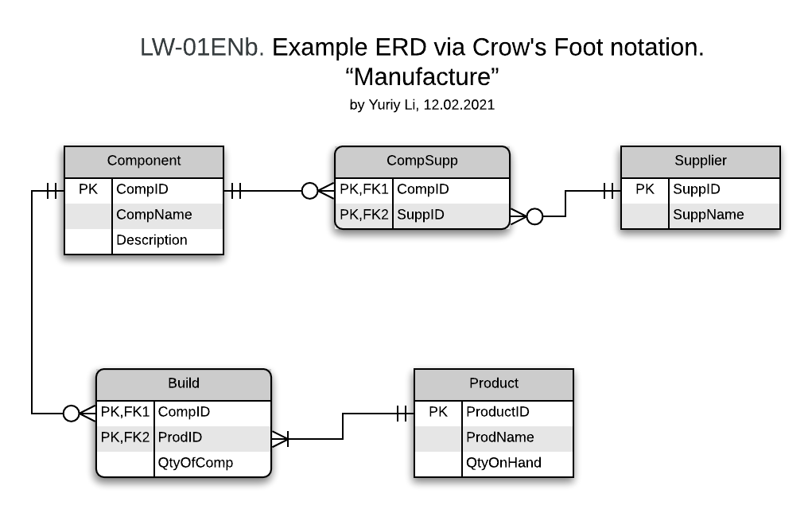

4.4. Publish Link to ERD “Manufacture”
a) Link to ERD for Draw.io
https://viewer.diagrams.net/?highlight=0000ff&edit=_blank&layers=1&nav=1&title=LW01ENa-ERD-Chen.drawio#R7Vxbd5s4EP41Prv7YB9dQNiP8WXbbps03Wyb9mmPDLLhlFsBN05%2F%2FUogbEC4trGN7XRfEjSIQZr5ZvRJTNLBI2%2F5KqKhfRtYzO0gYC07eNxByEA6%2FykEz5kAEgwyyTxyLClbCx6cH0wK824Lx2JxqWMSBG7ihGWhGfg%2BM5OSjEZR8FTuNgvc8ltDOmeK4MGkrip9dKzEzqR9ZKzlr5kzt%2FM3QzLI7ng07yxnEtvUCp4KIjzp4FEUBEl25S1HzBXGy%2B3y%2BOb50X33lbz660P8jX4cvv3n7lM3U%2FbnPo%2BsphAxP2msmoBbQ%2Fv45sb9ZIRj6%2FGTwT7TXPV36i6kvR4WYeg6LJJzTp5zQz7ZTsIeQmqK9hMHSwcP7cRzeQvyS%2Bo6c59fm3yM%2FGk8nDmuOwrcIEofx7PZDJkml8dJFHxlhTsWmRKd8Ds7TjMfM4sStiw4WU77FQs8lkTPvIu8SzScPSIxjAYkaz%2BtAQGB9LJdAIMmZVRicL5SvbYzv5Cm3sPsSDH7fRRYCw7%2Fl2P1%2FqUZXas1%2BpuxYnOui2cn3hjubf3ATx6kIq0920J0bttCrBg3zhKJpZiX59FQXEZ24E0XfCTDkEUOH4cwYS69X4v290I5BizK%2BrPaGCBmn01nJ%2FSTNqgEQb%2FGUajGUeRkjlKjQMW%2Fb92IlZe3%2FMBnZWtHwcK3mHgF4C2LxnbagLJxTxPuBD%2BVIMBNM2RLJ%2Fkse4jrL%2BLRni5b46XUlDae84bP5%2Fq52Cg8JZrrx9JW%2Ftx%2BfoyDRWSynxhLMoGERnOW%2FKSfdBazSlRERUXEXJo438vMpM7F8tH7wOHzWKGpjCWRvUsKsunIZ4pEoKqmkj00UlGUzVdRlOJtNZsDIKgrELxTMBix2PlBp2kT1Md7lIXLUISjwwnfjZRPgyQJvFo0%2FDQkJAOVL13zvt3DXXr0QDd3YSX4g9ksZidxBVA8MQq8kMe8%2F5KYCCaXRkUGNUmYuALMcUh9fsel%2Fjy9Qb4txP5iOLnrfnxYN0uuyYWCfXRn1HNcPtGbjsAvoV6YdsdY8BEaOdRVpGnPkVBJ%2Fbgb85V3JkTpDTPzk9AWzae%2F6%2FqqM4HrS%2FxHcWhkLn%2B7%2Bag2DzdON4xCPUThUtXiUYvlmripM2XlF3BxZrWyWFpy63s9ZjkLb%2FP4FfW%2FLp1B8NLoTL6NPxKdWfEOuB%2FvyDlOfr0LxzkTV0Fn4SpGQ64CyRZFJ%2BYqqK%2Fg6%2FacXCXH%2B6VwFdQaVUHqmim273fUY2rEN97AnypzVhInPDsDwerJ3yGJ82XvA3PvbU2usKXkWjlWwE23gjraoujE6RWrB6Fn3QrmUXEp6XW1FZT%2B6eKeriMDYmL0%2BwDoALLVdvr0KRiTc%2BWMfXhVUw53rpzR1uHR0XJGhZLhfss5Q6X8Z6VkeVRcSs5oj5JhlRx%2FSJ7f%2B6%2Bpb10DJ9MvjZRp6nncfgl2zZd6RC%2BlvwYbWLg9zRaONU6RQ3OAHW1TW%2FCsXuPYXHboqm2UcGWghplWO%2B%2FeVzt0i1DH%2BHcAVYZfjIr47YIeQFtPYVqAJDr2OUs7kKykOg00PY%2Bpbhhgy5g89PPlKtGtWOReqNwrqR4ZetpVIg%2BCDR9f9odevww93C709PpaqausH6lWRJ2%2FgERXTwJ%2BmcDWdz02aidiyQD19HLMwkGzmK1RVQ3%2FU0etWpgkovZKjo2Nizs31o%2B2AO8cpceONnxR0WZouAeARggYcFa22ivk4aLjHtQQxDpB2MBgUDns2zUQq0BqPQzVmh9RaXKVi2e1nOQCFk%2F1YFZY90qSHBpcXJJTjxjHLDYjJ0ycwL8Ck2r44kyqnhXuuW405GpNeOGxVxyZ%2FI72KaClnVu1gr%2FpFwNIKju36unDqRefunK76%2BIsxv8IOieCyMEH8wcdhRoXeRSaO%2FPKQKn8TQZpuLnVNKOnE6gBrIO%2BYcBBeafbOkbrdmZZCauNS1DNK109PiDHz6pgkd4zQjE5YHr8JzR6UE%2FbKW7AlJpf5%2Bnn%2B6x7SnSOUPPbFzW%2F8h3pvSfpcHHXDyIvLVfe8JZDaqWPVdecyd49dgGc3NHeqrban8ZhofNupcuTJX%2BYDxSByd98rGBkM%2F%2B3OLVEQgX17G3XJ3y9oVKZk8eknJbKJcQybRXrjaVIIa7Vj%2BaeY1nuJgZcLvs4FedVPucChfJq%2BXpUTCvV7%2BVNKO%2F4Prbtfyev39uPJhiMyFTT39b8ccVLjccJ6vRBZzC6pf5iRs1kEbFcNn4xiFWQuCuINyPWgJXTUe3cmFW%2FcUzFgL8sIkf8fudkiREizkF6HKVwB5ft7opq1U4o1sp0ivqwo4%2BFrkUSZHBNVZ%2FKMzj%2Fzij90lf9ArUaitLAL7y5%2FhcCGRdY%2FyMGPPkP
b) Link to ERD for LucidChart.com
https://lucid.app/lucidchart/638996de-da78-4f4b-b555-75c69acda994/view?page=0_0#?folder_id=home&browser=icon
4.5. “Manufacture” Databases Scheme
Product{ProdID(int), ProdName(char), QtyOnHand(int); PK[ProdID]}
Component{CompID(int), CompName(char), Description(text, NULL); PK[CompID]}
Supplier{SuppID(int), SuppName(char); PK[SuppID]}
CompSupp{CompID(int), SuppID(int); PK[CompID, SuppID]; FK1[CompID]; FK2[SuppID]}
Build{CompID(int), ProdID(int), QtyOfComp(int); PK[CompID, ProdID]; FK1[CompID]; FK2[ProdID]}
Only one Attribute Component.Description may be Null, because the description may be missing and this will not affect database integrity.

