Home Work Report: Relational Database Design.
Student Name | Group ID | Date
Example Variant | EV-00 | 31.01.2025.
Solution.
0. Select Assignment Variant Nr.
Instruction:  The step by step formation of an individual variant of the assignment from the student name to the final number.  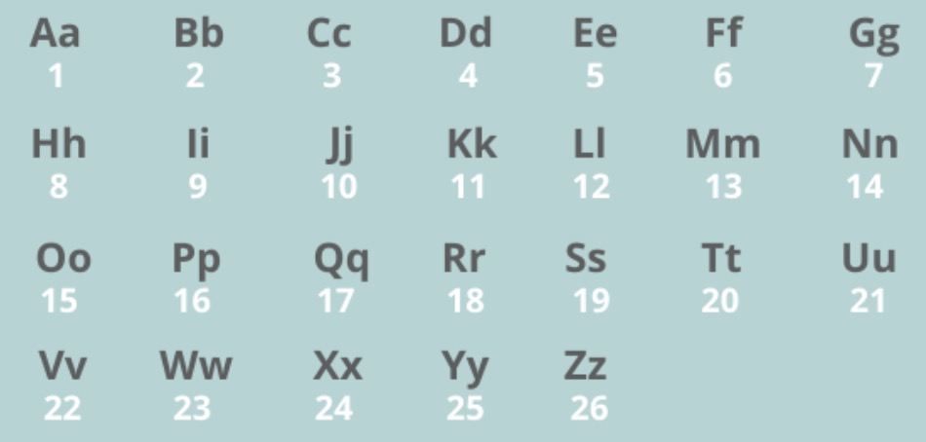 | Example:  a) Yuriy Li there will be LIYU  b) 12 09 25 21 18 09  c) (12+09+25+21+18+09)mod20+1=94mod20+1=14+1=15.  d) variant Nr.=15.
Text of Assignment.

1. HW-01EN. Conceptual Database Design.
Insert Subject Area Analyze, Restrictions, ERD into the report.
2. HW-02EN. Logical Database Design.
Insert Data Dictionary Table, RDM, Normalization checks into the report.
3. HW-03EN. Physical DB Design. SQL DDL/DML: Create, Insert Design.
Add Create, Insert SQL-scripts into the report.
4. HW-04EN. SQL DML: Select Scripts.
Add Select SQL-scripts into the report.
5. *HW-05EN (optional). SQL DDL/DML: View, Update, Delete Design.
Add Select SQL-scripts into the report.

